The Informal Labour Market in India: Transitory or Permanent Employment for Migrants?

P.N. (Raja) Junankar
University of New South Wales, University of Western Sydney, and IZA, Bonn
and
Abu Shonchoy
Institute of Developing Economies, Japan External Trade Organisation, Tokyo

Preliminary (Incomplete) Draft: Please do not quote without the prior permission of the authors.
Corresponding Author: raja.junankar@uws.edu.au
April 2012

The Informal Labour Market in India: Transitory or Permanent Employment for Migrants?

Abstract

The informal economy is a very important sector of the Indian economy: the National Council of Applied Economic Research estimates that the informal sector -“unorganised sector”- generates about 62 % of GDP, 50 % of national savings and 40 % of national exports, (ILO 2002, p. 30). In terms of employment, the informal economy provides for about 55 % of total employment (ILO 2002, p. 14). This paper studies the characteristics of the workers in the informal economy and whether migrants treat this sector as a permanent base or only as a temporary location before moving on to the organised or formal sector to improve their life time income and life style. We limit our study to the Indian urban (non-Agricultural) sector and study the characteristics of the household heads that belong to the Informal Sector (Self Employed and Informal Wage Workers) and the Formal Sector. We find that members who come from the lower social groups (castes and religions) are more likely to be in the informal sector. We distinguish between migrants who come from rural areas and urban areas to their present urban location. We find that the longer duration of a rural migrant in the urban area, the lower the probability that the household head would be in the informal sector.
The Informal Labour Market in India: Transitory or Permanent Employment for Migrants?
P.N. (Raja) Junankar and Abu Shonchoy
- Introduction
The informal economy is a very important sector of the Indian economy: the National Council of Applied Economic Research estimates that the informal sector -“unorganised sector”- generates about 62 % of GDP, 50 % of national savings and 40 % of national exports, (ILO 2002, p. 30). In terms of employment, the informal economy provides for about 55 % of total employment (ILO 2002, p. 14). Urban areas (especially large cities) attract numerous migrants from both the rural areas and from smaller urban towns and cities in the hope of a better life.
This paper is interested in studying the characteristics of the workers in the informal economy and whether migrants treat this sector as a permanent base or only as a temporary location before moving on to the organised or formal sector to improve their life time income and life style. We limit our study to the Indian urban (non-Agricultural) sector and study the characteristics of the household heads that belong to the Informal Sector (Self Employed and Informal Wage Workers) and the Formal Sector. We find that members who come from the lower social groups (castes and religions) are more likely to be in the informal sector. We distinguish between migrants who come from rural areas and urban areas to their present urban location. We find that the longer duration of a rural migrant in the urban area, the lower the probability that the household head would be in the informal sector.
The Indian labour market can be conceived of as a segmented market: a formal sector with workers who have salaried work, with good working conditions, and of course organised business. The informal economy would consist of small self employed traders and business people, and casual workers in the informal or formal sectors. Some individuals are born into wealthy families who own large businesses and hence are in the formal sector by right of birth. Others who are born with parents from the professional classes would almost certainly have education from good schools and universities, and have a network of contacts that would ensure that they would also join the ranks of employment in the formal sector. Some individuals may have over time built up sufficient assets to set up small businesses and hence enter the formal sector. However, most workers in the formal sector enter the formal sector through their educational achievements, or by birth (children of rich people) and through social networks. For someone who comes from a poor background (either in terms of income, or belonging to a socially disadvantaged caste or religion) the only way to enter the formal sector is via education in “good schools or universities”. Even with a good education, entry into the formal sector is often based on family connections. The Indian government has for some time had a policy of positive discrimination for the Dalits and as a result they may have a higher probability of finding a job in the formal (Government) sector. Migrants (especially from rural areas) who come into urban areas would likely have to spend time working in the informal sector for some time before they build good networks to enable them to move into the formal sector.
- The Informal Labour Market: Definitions: review of some earlier studies
In most developing countries there is a large sector of the economy that is called the informal sector or the unorganised sector. Employment in the informal labour market plays an important role in most developing economies. Very broadly, the informal labour market consists of workers in the informal sector plus casual workers in the formal sector. The informal labour market is a very large part of the agricultural sector, but is also a significant part of the urban sector. There is a difference between employment in the formal sector and the informal sector in terms of the conditions of work, whether they are subject to government taxes, have access to social security, casual or contract workers, whether they receive minimum wages or not, etc.
In the developing country context, the informal sector is sometimes defined in terms of the activities of the enterprises (ILO, 1972) and sometimes in terms of the kind of work done by individuals as employees or as self-employed people (Hart, 1973).
In 1972 the ILO characterised the informal sector as:
- Ease of entry
- Reliance on indigenous resources
- Family ownership of enterprise
- Small scale of operation, often defined in terms of hired workers less than (say) ten
- Labour-intensive methods of production and adapted technology
- Skills acquired outside the formal school system
- Unregulated and competitive markets
The formal sector was characterised by:
- Difficult entry
- Frequent reliance on overseas resources
- Corporate ownership
- Large scale of operation
- Capital-intensive and often imported technology
- Formally acquired skills, often expatriate
- Protected markets (through tariffs, quotas, and licences)

Hart (1973) discussed the informal sector in terms of the conditions of work of the individuals and whether they worked for wages with good conditions or informally as self-employed workers. Informal activities included:
- Farming, market gardening, self employed artisans, shoe makers, tailors, etc.
- Working in construction, housing, road building
- Small scale distribution, e.g. petty traders, street hawkers, caterers in food and drink, etc.
- Other services, e.g. barbers, shoe-shiners etc.
- Beggars
- Illegal activities like drug pushing
Formal sector income earning activities included:
- Public sector wage earners
- Private sector wage earners (on permanent contracts, not casual workers)

Sengupta (2009, p. 3) defines the informal economy thus:
Informal Sector: The unorganised sector consists of all unincorporated private enterprises owned by individuals or households engaged in the sale and production of goods and services operated on a proprietary or partnership basis and with less than ten total workers.
Informal worker/employment: Unorganised workers consist of those working in the unorganised sector or households, excluding regular workers with social security benefits provided by employers and the workers in the formal sector without any employment and social security benefits provided by employers.
Informal economy: The informal sector and its workers plus the informal workers in the formal sector constitute the informal economy.
The literature on the role of the informal sector in developing countries has oscillated between treating the informal sector as a backward sector that is holding back economic development to a dynamic sector that is helping to develop the economy rapidly without straining the foreign currency balances and with relatively low demands for (real) capital goods, see Mazumdar (1976), Weeks (1975), Bromley (1978), Gerxhani (2004). The informal sector is considered as a pre-capitalist form of production compared to the formal sector that is a profit maximising capitalist sector. There is a large literature on rural-urban migration (see, Harris and Todaro, 1970) that considers migrants arriving in the city and initially finding work in the informal sector and then moving on to better paid work in the formal sector. This view of the informal sector as a temporary abode for migrants has been disputed (amongst others) by Mazumdar (1976). The debate has also ranged over whether informal sector workers are living in poor conditions with low incomes, or whether some of the informal sector workers are there out of choice and have a comfortable life, see Meng (2001). Some individuals may have employment in the formal sector and work in the informal sector as well.
Some of the important issues to investigate are whether (1) individuals who are informal sector workers are migrants; whether migrants move out of the informal sector into the formal sector after a few years; (2) whether they are from disadvantaged social and ethnic groups who do not have social networks to enter the formal sector; (3) whether those with low levels of education and skills are unable to enter formal sector employment and have to find low paid work in the informal sector; and finally, (4) whether the incomes of worker in the informal sector are lower than in the formal sector; and whether there are some well paid informal sector workers.

- The Indian Informal Labour Market: Some Background Information
A recent Report of the National Commission for Enterprises in the Unorganised Sector by the Government of India (Sengupta, 2009) finds that 86 % of the total employment in 2004-2005 was in the informal sector. Further, the agricultural sector consists almost entirely of informal workers. The non-agricultural workers in the informal sector were 36.5 % of the total, most of whom were self-employed. From 1999-2000 to 2004-2005 most of the increase in employment in the formal sector was of informal workers! (Sengupta, 2009, p. 14). The NSSO (2012, p ii) document finds that in 2009-2010 in the non-agriculture sector , nearly 71 % of the workers in rural areas and 67 % in the urban areas worked in the informal sector. It finds that the informal sector activities are concentrated mainly in the manufacturing, construction, wholesale and retail trades, and transport, storage and communication industries.
In our study we are using data from the India Human Development Survey (IHDS), 2005 conducted by the Inter-university Consortium for Political and Social Research, Ann Arbor, Michigan, USA. The survey is a nationally representative, multi-topic survey of 41,554 households in 1,503 villages and 971 urban neighbourhoods across India. The data set has detailed information on household employment by industry and occupation, and detailed information about household characteristics including age, education, ethnicity, religion, and migration status. In this study we have limited our analysis to the informal labour markets in the urban sector who are not engaged in any agricultural activities.
Our data set consists of 12,056 heads of households for whom we had data on their age, education, marital status, gender, religion, caste, income source, migration status and years since migration to urban sector, slum dwelling, and assets, etc.
We define the Urban Informal Sector as artisans, petty traders, small business (who do not hire any labour), and non-Agricultural casual workers in the Informal or Formal Sectors. The Informal Sector consists of the Self-Employed and Informal Wage Labour. We define Self-Employment as Petty Traders who do not hire any workers and those in the Organised Trade/Business category who do not hire any workers. Note that this is a stricter definition than that suggested by, for example, Sengupta (2009). The Informal Wage Labour category covers those who are in the Informal Sector but are not Self-Employed, that is, the Artisans, and Non-Agricultural Labour who are casually employed. The Formal Sector consists of Salaried Employment, Professionals, and Organised Trade/Business who hire workers. In our study we are limiting our analysis to only Heads of Household. An Appendix provides details of how we derived our sample from the India Human Development Survey.
It is interesting to see the Industry and Occupational distribution of the Formal and Informal Sectors of the economy for our sample data. Most of the Informal Wage Labour is in Manufacturing, Construction, Wholesale, Retail trades, Restaurants, and Hotels, and in Community, Social and Personal Services. Self-Employment is concentrated (not surprisingly) in the Wholesale, Retail trades, Restaurants, and Hotels. Informal Wage Labour is concentrated in occupations: Production and Related Workers, Transport Equipment Operators and Labourers (presumably the unskilled workers).
Table 1: Distribution of Households over Industries
Industry | Formal | Self-Employment | Informal Wage Labour | Total
MINING AND QUARRYING | 148 | 4 | 31 | 183
MANUFACTURING | 942 | 101 | 684 | 1,727
ELECTRICITY, GAS AND WATER | 264 | 4 | 28 | 296
CONSTRUCTION | 162 | 10 | 830 | 1,002
WHOLESALE AND RETAIL TRADE AND RESTAURANTS AND HOTELS | 963 | 954 | 695 | 2,612
TRANSPORT, STORAGE AND COMMUNICATION | 846 | 65 | 463 | 1,374
FINANCING, INSURANCE, REAL ESTATE AND BUSINESS SERVICES | 471 | 20 | 41 | 532
COMMUNITY, SOCIAL AND PERSONAL SERVICES | 2,021 | 157 | 638 | 2,816
Total | 5,817 | 1,315 | 3,410 | 10,542
Source: India Human Development Survey
Table 2: Distribution of Households over Occupations
Occupation | Formal | Self-Employment | Informal Wage Labour | Total
Professions, Technical and Related Workers | 895 | 17 | 83 | 995
Administrative, Executive and Managerial Workers | 829 | 304 | 422 | 1,555
Clerical and Related Workers | 1,217 | 2 | 31 | 1,250
Sales Workers | 946 | 980 | 622 | 2,548
Service Workers | 626 | 18 | 217 | 861
Production and Related Workers, Transport Equipment Operators and Labourers | 1,449 | 1 | 2,276 | 3,726
Total | 5,962 | 1,322 | 3,651 | 10,935
Source: India Human Development Survey
If we look at the distribution of migrants over these sectors we find that 64 % of the migrants work in the Formal sector, almost 10 % are self employed and 27 % are informal wage workers. However, the Formal sector has almost an equal proportion of migrants and non-migrants, and 38 % of the self employed are migrants, and 38 % of the informal wage workers are migrants.
Table 3: Migrants in Different Sectors
Migrant | Formal | Self-employment | Informal Wage Labour | Total
0 | 3,511 | 820 | 2,337 | 6,668
 | 52.65 | 12.3 | 35.05 | 100
 | 50.43 | 61.75 | 62.06 | 55.31
1 | 3,451 | 508 | 1,429 | 5,388
 | 64.05 | 9.43 | 26.52 | 100
 | 49.57 | 38.25 | 37.94 | 44.69
Total | 6,962 | 1,328 | 3,766 | 12,056
 | 57.75 | 11.02 | 31.24 | 100
 | 100 | 100 | 100 | 100
Source: India Human Development Survey

A high proportion of Migrants (28 %) are working primarily in the Community, Personal and Social Services, 21 % in Wholesale & Retail Trades, Restaurants and Hotels, and 17 % in Manufacturing.
Table 4: Migrants by Industry
Industry | Non-Migrant | Migrant | Total
Mining | 82 | 101 | 183
 | 44.81 | 55.19 | 100
 | 1.41 | 2.13 | 1.74
Manufacturing | 930 | 797 | 1,727
 | 53.85 | 46.15 | 100
 | 16.03 | 16.81 | 16.38
Electricity, Gas, Water | 124 | 172 | 296
 | 41.89 | 58.11 | 100
 | 2.14 | 3.63 | 2.81
Construction | 601 | 401 | 1,002
 | 59.98 | 40.02 | 100
 | 10.36 | 8.46 | 9.5
Wholesale, Retail, Restaurants | 1,602 | 1,010 | 2,612
 | 61.33 | 38.67 | 100
 | 27.62 | 21.3 | 24.78
Transport | 712 | 662 | 1,374
 | 51.82 | 48.18 | 100
 | 12.28 | 13.96 | 13.03
Finance | 273 | 259 | 532
 | 51.32 | 48.68 | 100
 | 4.71 | 5.46 | 5.05
Community, Social, Personal Services | 1,476 | 1,340 | 2,816
 | 52.41 | 47.59 | 100
 | 25.45 | 28.26 | 26.71
Total | 5,800 | 4,742 | 10,542
 | 55.02 | 44.98 | 100
 | 100 | 100 | 100
Source: India Human Development Survey

Table 5: Migrants by Occupation
Occupation | Non-Migrant | Migrant | Total
Professions, Technical and Related Workers | 425 | 570 | 995
 | 42.71 | 57.29 | 100
 | 7.06 | 11.6 | 9.1
Administrative, Executive and Managerial Workers | 865 | 690 | 1,555
 | 55.63 | 44.37 | 100
 | 14.37 | 14.04 | 14.22
Clerical and Related Workers | 620 | 630 | 1,250
 | 49.6 | 50.4 | 100
 | 10.3 | 12.82 | 11.43
Sales Workers | 1,591 | 957 | 2,548
 | 62.44 | 37.56 | 100
 | 26.43 | 19.47 | 23.3
Service Workers | 458 | 403 | 861
 | 53.19 | 46.81 | 100
 | 7.61 | 8.2 | 7.87
Production and Related Workers, Transport Equipment Operators and Labourers | 2,061 | 1,665 | 3,726
 | 55.31 | 44.69 | 100
 | 34.24 | 33.88 | 34.07
Total | 6,020 | 4,915 | 10,935
 | 55.05 | 44.95 | 100
 | 100 | 100 | 100
Source: India Human Development Survey
Of the migrants a high proportion (34 %) are in the occupation Production and Related Workers, Transport Equipment Operators and Labourers, and almost 20 % are Sales and Service workers.
Table 6: Migrants and Income Source
Income source | Non-Migrant | Migrant | Total
Non-Ag labour | 1,627 | 980 | 2,607
 | 62.41 | 37.59 | 100
 | 24.4 | 18.19 | 21.62
Artisan | 754 | 482 | 1,236
 | 61 | 39 | 100
 | 11.31 | 8.95 | 10.25
Petty trade | 654 | 400 | 1,054
 | 62.05 | 37.95 | 100
 | 9.81 | 7.42 | 8.74
Business | 999 | 599 | 1,598
 | 62.52 | 37.48 | 100
 | 14.98 | 11.12 | 13.25
Salaried | 2,521 | 2,818 | 5,339
 | 47.22 | 52.78 | 100
 | 37.81 | 52.3 | 44.29
Profession | 113 | 109 | 222
 | 50.9 | 49.1 | 100
 | 1.69 | 2.02 | 1.84
Total | 6,668 | 5,388 | 12,056
 | 55.31 | 44.69 | 100
 | 100 | 100 | 100
Source: India Human Development Survey
It is interesting to note that the main source of migrants was Salaried (52 % of the migrants), and 19 % of migrants were in Non-Agricultural Labour.

It is interesting to see the caste and religion breakdown for the Formal and Informal Sectors (Self Employed and Informal Wage Labour). As we would suspect, Brahmins and High Caste people are more likely to be in the Formal Sector, compared to the lower social castes and Muslims.
Table 7: Caste and Religion by Sector
 | Formal | Self-Employment | Informal Wage Labour | Total
Brahmin | 837 | 91 | 147 | 1,075
High caste | 1,862 | 352 | 523 | 2,737
OBC | 1,890 | 448 | 1,255 | 3,593
Dalit | 997 | 121 | 785 | 1,903
Adivasi | 282 | 26 | 95 | 403
Muslim | 751 | 246 | 863 | 1,860
Sikh, Jain | 177 | 37 | 42 | 256
Christian | 166 | 7 | 56 | 229
Total | 6,962 | 1,328 | 3,766 | 12,056
Source: India Human Development Survey
If we look at the distribution of people by caste and religion for the principal source of the household incomes we see that Brahmins and High Caste people are more likely to be Salaried or Professionals, whilst Dalits and Muslims are more likely to be Non-Agricultural labourers or artisans.
Table 8: Caste and Religion by Source of Income
 | Non-Ag labour | Artisan | Petty traders | Business | Salaried | Professionals | Total
Brahmin | 56 | 67 | 68 | 136 | 705 | 43 | 1,075
High caste | 254 | 182 | 277 | 536 | 1,429 | 59 | 2,737
OBC | 875 | 437 | 341 | 446 | 1,438 | 56 | 3,593
Dalit | 664 | 205 | 105 | 108 | 803 | 18 | 1,903
Adivasi | 97 | 11 | 16 | 35 | 238 | 6 | 403
Muslim | 598 | 295 | 211 | 256 | 471 | 29 | 1,860
Sikh, Jain | 9 | 20 | 32 | 61 | 129 | 5 | 256
Christian | 54 | 19 | 4 | 20 | 126 | 6 | 229
Total | 2,607 | 1,236 | 1,054 | 1,598 | 5,339 | 222 | 12,056
Source: India Human Development Survey
When we look at the distribution of occupations by caste and religion we note that Brahmins and High Caste people are more likely to be in the higher level occupations, while Dalits and Muslims are more likely to be in the lower level occupations.
Table 9: Caste and Religion by Occupation
 | Brahmin | High caste | OBC | Dalit | Adivasi | Muslim | Sikh, Jain | Christian | Total
Professions, Technical and Related Workers | 195 | 280 | 245 | 105 | 49 | 72 | 27 | 22 | 995
Administrative, Executive and Managerial Workers | 135 | 357 | 427 | 147 | 28 | 243 | 35 | 27 | 1,399
Clerical and Related Workers | 188 | 329 | 361 | 191 | 50 | 84 | 23 | 24 | 1,250
Sale Workers | 190 | 746 | 765 | 235 | 52 | 445 | 97 | 21 | 2,551
Service Workers | 71 | 172 | 210 | 248 | 44 | 87 | 11 | 18 | 861
Production, Transport and Labourers | 159 | 551 | 1,236 | 799 | 141 | 732 | 41 | 67 | 3,726
Missing | 137 | 302 | 349 | 178 | 39 | 197 | 22 | 50 | 1,274
Total | 1,075 | 2,737 | 3,593 | 1,903 | 403 | 1,860 | 256 | 229 | 12,056
Source: India Human Development Survey
When we look at the distribution of industries that the different castes and religions are located in, we see that Manufacturing, Transport, and Finance etc. are important for most groups.
If we now look at the distribution of household incomes we find that the formal sector households are more likely to be in the upper deciles, while informal wage labourers are more likely to be in the lower income deciles. The self-employed households fall somewhere between the other two groups. It is interesting to see that there are some very high income households in the top two deciles who are either self employed (10 %) or informal wage labourers (5 %). Similarly, it is interesting to note that there are some formal sector households (6 %) that are in the lower income deciles.
Table 10: Income Distribution by Sector
Income deciles | Formal | Self-employment | Informal  Wage Labour | Total
1 | 384 | 136 | 650 | 1,170
 | 32.82 | 11.62 | 55.56 | 100
 | 5.52 | 10.24 | 17.26 | 9.7
2 | 354 | 154 | 660 | 1,168
 | 30.31 | 13.18 | 56.51 | 100
 | 5.08 | 11.6 | 17.53 | 9.69
3 | 381 | 159 | 665 | 1,205
 | 31.62 | 13.2 | 55.19 | 100
 | 5.47 | 11.97 | 17.66 | 10
4 | 543 | 172 | 497 | 1,212
 | 44.8 | 14.19 | 41.01 | 100
 | 7.8 | 12.95 | 13.2 | 10.05
5 | 615 | 171 | 421 | 1,207
 | 50.95 | 14.17 | 34.88 | 100
 | 8.83 | 12.88 | 11.18 | 10.01
6 | 732 | 164 | 320 | 1,216
 | 60.2 | 13.49 | 26.32 | 100
 | 10.51 | 12.35 | 8.5 | 10.09
7 | 884 | 124 | 197 | 1,205
 | 73.36 | 10.29 | 16.35 | 100
 | 12.7 | 9.34 | 5.23 | 10
8 | 954 | 114 | 159 | 1,227
 | 77.75 | 9.29 | 12.96 | 100
 | 13.7 | 8.58 | 4.22 | 10.18
9 | 1,019 | 79 | 124 | 1,222
 | 83.39 | 6.46 | 10.15 | 100
 | 14.64 | 5.95 | 3.29 | 10.14
10 | 1,096 | 55 | 73 | 1,224
 | 89.54 | 4.49 | 5.96 | 100
 | 15.74 | 4.14 | 1.94 | 10.15
Total | 6,962 | 1,328 | 3,766 | 12,056
 | 57.75 | 11.02 | 31.24 | 100
 | 100 | 100 | 100 | 100
Source: India Human Development Survey
Note: Row and column percentages below the numbers in each category

We now turn to looking at some information about whether people in the different sectors are below the poverty line based on per capital consumption levels, (Planning Commission definition). We find that a very high proportion of the Informal Wage labourers (31 %) are below the poverty line, while a relatively small percentage (18 %) of the self employed is below the poverty line. However, a very small percentage of Formal sector households are below the poverty line (10 %).
Table 11: Poverty by Sector
Source: India Human Development Survey
Note: Row and column percentages below the numbers in each category.
Table 12: Poverty by Caste and Religion
Source: India Human Development Survey
Note: Row percentages below the numbers in each category.
To look at the distribution of different castes and religions by whether they are above or below the poverty line, we can see that almost all the Brahmins and High Caste households are above the poverty line, but high percentages of Dalits, Adivasis and Muslims are below the poverty line.
If we now look at whether households from formal and informal sectors were better off or not compared to the last ten years we see that of the Formal sector households only 7 % were worse off, but almost 15 % of self employed and informal wage labourers were worse off.
Table 13: Improvement over last ten years by Sector
Better off last 10 yrs | Formal | Self-employment | Informal Wage Labour | Total
Don't know | 5 | 0 | 2 | 7
 | 71.43 | 0 | 28.57 | 100
 | 0.07 | 0 | 0.05 | 0.06
Valid blank | 1 | 0 | 0 | 1
 | 100 | 0 | 0 | 100
 | 0.01 | 0 | 0 | 0.01
Same | 1,747 | 434 | 1,524 | 3,705
 | 47.15 | 11.71 | 41.13 | 100
 | 25.09 | 32.68 | 40.47 | 30.73
Better | 4,714 | 703 | 1,673 | 7,090
 | 66.49 | 9.92 | 23.6 | 100
 | 67.71 | 52.94 | 44.42 | 58.81
Worse | 495 | 191 | 567 | 1,253
 | 39.51 | 15.24 | 45.25 | 100
 | 7.11 | 14.38 | 15.06 | 10.39
Total | 6,962 | 1,328 | 3,766 | 12,056
 | 57.75 | 11.02 | 31.24 | 100
 | 100 | 100 | 100 | 100

Source: India Human Development Survey
Note: Row and column percentages below the numbers in each category.
- The Informal Economy: Some Analytical Features
We assume that individuals would prefer to be employed in the formal sector, either as employees, or as owners/managers in the formal sector. This is based on the idea that the formal sector provides a better life not only in terms of present and future income, but also in terms of better conditions of work (security of tenure, social security benefits, access to unions, safer working conditions, etc). If they are unable to enter the formal sector, we assume that they would prefer to be self-employed (as long as their expected incomes are not below that in the informal wage sector). Employees in the informal wage sector would prefer to become self-employed if they had access to credit to set up a small business. Many of them may simply be “waiting” for a job in the formal sector. In the Harris-Todaro model, rural migrants come to the urban area as long as their expected wages (urban wage multiplied by the probability of finding a job) are greater than their rural subsistence wage. Migrants who do not find work in the urban formal sector then enter the urban informal sector which is meant to be a form of “wait unemployment”. Essentially, we are arguing that individuals have a hierarchy of preferences over these outcomes.
In fact if we look at the actual incomes (based on our sample) we find that the incomes of these three groups overlap to some extent, with the lowest incomes for informal wage labour, followed by self-employment, followed by formal sector incomes. The table presented below provides some summary statistics. As discussed above the mean (log) incomes of the formal sector is greater than that of the self employed and that is greater than the informal wage workers. The only curious result seems to be that the minimum of the formal sector is lower than that of the other two groups. This is shown below in the kernel density plots for log incomes of these groups.
Table 14: Distribution of Log Incomes by Sector
 | Obs | Mean | Std. Dev. | Min | Max
loginc (Formal) | 6916 | 11.2313 | 0.81603 | 6.21461 | 15.6904
loginc (Self-Employment) | 1324 | 10.7466 | 0.76783 | 6.8024 | 13.7695
loginc (Informal Wage Labour) | 3744 | 10.4617 | 0.70924 | 6.44883 | 13.731
Source: India Human Development Survey

Figure 1: Kernel Densities of Log Income by Sector
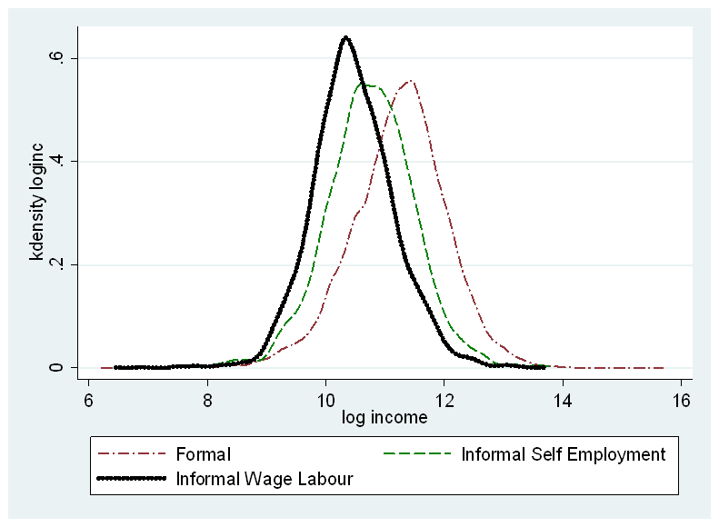

To be in the Formal sector, domestic capitalists need to have significant amounts of capital and access to credit. Inheritance plays a large part in providing either the original capital or access to credit. Multinationals come in with large amounts of capital with technology that is labour saving. Employment in the Formal sector is then limited by the use of imported technology and limited amounts of capital. Note there is limited amount of labour-capital substitution possible.
Wages in Formal Sector fixed by government (minimum wages) or by unions or by employers using efficiency wage ideas, or by Multinational Firms. Employers in Formal Sector ration employment by using education/experience as an index of productivity, and using religion/caste as a signal for productivity (statistical discrimination). Given two people with the same education/skill levels they would prefer a high caste Hindu to a low caste Hindu or to a Muslim. Note: being in the formal economy is not a guarantee against poverty, (see ILO 2002, p.31)
Self employment (in the Informal Sector) is limited by limited amounts of credit and access to capital. The higher the social class and the higher the level of education, the easier people have access to credit. Note: ILO (2002, p. 31) provides evidence that many in the informal economy, especially the self employed, in fact earn more than unskilled or low-skilled workers in the formal economy.
Informal Sector employment is a residual: the lower the employment in the Formal Sector, the greater the number who looks for work in the informal sector and hence, the lower the wages (incomes) for this sector.
The table below shows that 43 % of the self employed have taken out loans for business purposes, compared to only 14 % of the Formal Sector, and 16 percent of the Informal Wage labour group. It is clear that the self employed have to take out loans for setting up and running a small enterprise. Presumably many of the informal wage workers would be interested in setting up a small business but are unable to access credit.
Table 15: Purpose of Loan by Sector
Loan Purpose | Formal | Self-employment | Informal Wage Labour | Total
House | 630 | 64 | 270 | 964
 | 65.35 | 6.64 | 28.01 | 100
 | 30.58 | 14.55 | 18.47 | 24.33
Land | 27 | 3 | 16 | 46
 | 58.7 | 6.52 | 34.78 | 100
 | 1.31 | 0.68 | 1.09 | 1.16
Marriage | 310 | 55 | 218 | 583
 | 53.17 | 9.43 | 37.39 | 100
 | 15.05 | 12.5 | 14.91 | 14.71
Ag/business | 281 | 189 | 226 | 696
 | 40.37 | 27.16 | 32.47 | 100
 | 13.64 | 42.95 | 15.46 | 17.57
Consumption | 202 | 30 | 280 | 512
 | 39.45 | 5.86 | 54.69 | 100
 | 9.81 | 6.82 | 19.15 | 12.92
Car/appliance | 92 | 5 | 17 | 114
 | 80.7 | 4.39 | 14.91 | 100
 | 4.47 | 1.14 | 1.16 | 2.88
Education | 111 | 8 | 56 | 175
 | 63.43 | 4.57 | 32 | 100
 | 5.39 | 1.82 | 3.83 | 4.42
Medical | 234 | 60 | 284 | 578
 | 40.48 | 10.38 | 49.13 | 100
 | 11.36 | 13.64 | 19.43 | 14.59
Other | 173 | 26 | 95 | 294
 | 58.84 | 8.84 | 32.31 | 100
 | 8.4 | 5.91 | 6.5 | 7.42
Source: India Human Development Survey
To summarise this section, we argue that households have a lexicographic preference ordering over the different outcomes, formal, self-employment, or informal wage labour. Migrants, especially rural migrants would have little access to credit or to the formal labour market, at least until they have spent some years in the urban sector.
- Probability of working in the Informal Sector
In this section we estimate the probability of a household head working in the Informal Wage employment sector, be Self-employed, or in the Formal Sector. As discussed earlier our hypotheses are that those households who come from the lower social classes/groups are more likely to be working in the Informal Sector. Some of these households may have the entrepreneurial skills or have access to small amounts of capital to set up as self-employed workers. We hypothesise that households who come from higher social classes/groups, and/or who have higher levels of education are more likely to be working in the Formal sector. Further we hypothesise that migrants who come into the urban sector would initially find employment in the Informal sector and after some time when they have accumulated sufficient funds or developed social networks are more likely to move into the Formal sector. In our analysis below we distinguish between migrants whose origin is a rural area from those who have come from other urban areas. We argue that migrants who come from rural areas are more likely, ceteris paribus, to work in the informal sector. In particular we expect that the duration of migration influences the sector of employment, especially for the rural migrants.
5.1 Identification Strategy
The fundamental challenge of estimating the causal impact of migration duration on the probability of working in the informal sector is the possibility of unobserved individual characteristics that might influence the migration decision and duration as well as the likelihood of working in the informal sector. For example, it might be possible that individuals with high unobserved ability or entrepreneurial skills might opt to move out of the rural area early in their life and such unobserved skills and ability will also influence their choice of sector in the migration destination. Without controlling for this, estimation could be biased and inconsistent.
If we had panel data we could have used methods to control for individual heterogeneity. Another ideal method that could be used to disentangle such unobserved influences on migration duration and job status would be by using some natural experimental framework or by randomly inducing people to migrate out of the rural areas to estimate the causal impact of migration on job choice. Lacking the availability of such methods, we need to opt for an instrumental variable approach (IV) where we would instrument the migration with a set of variables which do not have a direct influence on job placement or current job status. One instrument that has been recently used to instrument for migration is the historic migration rate as an instrument for current migration status (for example see, Woodruff and Zenteno (2007), Hanson and Woodruff (2003); McKenzie and Rapoport (2007); López-Córdoba (2005); and Hildebrandt and McKenzie (2005)).
Following these sets of influential work, we therefore used the historic state-level migration rates as an instrument for current migration duration. In particular, we use the Indian migration rates from data collected from the 1991 census at the state level and use this variable as an instrument in which the household is currently located.
These historic migration rates can be argued to be the result of the massive development of railroad and other transportation system in India coupled with rapid economic expansion of large cities which created extended job demand. These historic migration rates can also be considered as signal of migration friendliness, strong migration networks which can effectively lower the cost of migration for future potential migrants, they become self-perpetuating, and as a result, continue to influence the migration decisions of households today.
Our identifying assumption is that historic state migration rates do not affect the current job placement of the individuals, apart from their influence through current migration. Instrumental variables estimation relies on this exogeneity assumption, and so it is important to consider and counteract potential threats to its validity.
One potential threat is that historic level of inequality and lower economic class (lower caste and religious group) could induce the historic migration rate and is also influencing the current one due to intergenerational transition. To tackle these potential pitfalls we also used amount of land holdings and interaction terms of stock of migration with the Dalit, Adivasi and Muslim dummies as additional instruments. One might argue that the amount of land holdings is endogenous however in numerous influential literature (for example Rozensweig 2001) has used land holding as an exogenous variable since the land market is very limited in India and in the sub-continent and the land holdings are mostly inherited. We have also controlled for City, State and District level fixed effects to control for spatial differences and location preferences.
  - Linear Probability Model
As discussed above we estimated a two stage least squares model for the probability of a household being in the Informal Sector as a function of demographic characteristics (age, age squared, marital status, gender, and household size). In addition we include various levels of education of the Household head and of his/her father’s education levels. We would expect the higher the education of the Head of Household the lower the probability of belonging to the informal sector. The evidence, see Table 16, shows clearly that the higher the level of education of the household head the lower the probability of being in the informal sector, and the coefficients get smaller (bigger in absolute value) respectively. The results for father’s education are very similar to the head’s education levels. Further, we would expect that if the father of the Head of Household was of a higher social class (in terms of occupation), the probability of being in the informal sector would be lower. Again the evidence supports the view that the parent’s occupation clearly influences the household head: if the father’s occupation is Professional or Executive, the probability of being in the informal sector is lower, while if the father’s occupation is Sales, then there is a higher probability of being in the informal sector. As discussed earlier we would expect a person from a socially disadvantaged caste, or religion would more likely be in the informal sector: we find that OBC (Other Backward Classes) and Muslims are more likely to be in the informal sector. Dalits and Adivasis (the lower social castes) are not significantly less likely to be in the informal sector. Perhaps, the government’s positive discrimination in employment in the Government sector has made an impact. As we would expect the wealthier the household head, the less likely s/he would be in the informal sector.
One of the main variables of interest is the Rural Migration Duration: in all cases it is negative and significant at the 5 % level. In other words, the longer a rural migrant has been in the urban area the less likely s/he would be in the informal sector and would have moved to the formal sector. (Note the Rural Migration Duration variable has been instrumented).
These results are more or less consistent for different samples: for the full sample of males and females, for males only, for the full sample without urban migrants, and for males only without the urban migrants. Results are generally stronger for the latter sample.

Table 16: 2SLS Estimates of Probability (Informal)
 | All  (1) | Only Male  (2) | Dropping Urban Migrants  (3) | Dropping Urban Migrants and Females (4)
Rural Migration Duration | -0.038**  (0.016) | -0.037**  (0.017) | -0.023**  (0.009) | -0.022**  (0.010)
Urban Migration Duration | -0.034  (0.037) | -0.032  (0.035)
Age | 0.00037  (0.007) | 0.00055  (0.008) | -0.0037  (0.004) | -0.0040  (0.005)
Age Square | 0.000069*  (0.000) | 0.000063  (0.000) | 0.000060*  (0.000) | 0.000061  (0.000)
Male | 0.18***  (0.025) |  | 0.19***  (0.022)
Household Size | 0.0082  (0.005) | 0.0088  (0.005) | 0.0083***  (0.003) | 0.0090***  (0.003)
Married | 0.027  (0.042) | 0.013  (0.044) | 0.030  (0.041) | 0.022  (0.044)
Primary Education | -0.055**  (0.026) | -0.031  (0.027) | -0.045*  (0.024) | -0.022  (0.025)
Secondary Education | -0.13***  (0.023) | -0.11***  (0.025) | -0.13***  (0.021) | -0.11***  (0.022)
Matric Completed | -0.24***  (0.031) | -0.23***  (0.031) | -0.24***  (0.023) | -0.23***  (0.024)
Tertiary Education | -0.32***  (0.026) | -0.31***  (0.027) | -0.30***  (0.024) | -0.29***  (0.025)
Graduate | -0.38***  (0.034) | -0.38***  (0.034) | -0.37***  (0.023) | -0.37***  (0.024)
High caste | 0.023  (0.025) | 0.022  (0.026) | 0.022  (0.020) | 0.024  (0.021)
OBC | 0.034  (0.026) | 0.039  (0.026) | 0.047**  (0.021) | 0.054**  (0.022)
Dalit | -0.0038  (0.030) | -0.0095  (0.030) | 0.0079  (0.022) | 0.0041  (0.023)
Adivasi | -0.091*  (0.052) | -0.086*  (0.051) | -0.051  (0.037) | -0.045  (0.038)
Muslim | 0.054  (0.036) | 0.067**  (0.034) | 0.074***  (0.026) | 0.086***  (0.027)
Sikh, Jain | -0.00073  (0.049) | -0.011  (0.050) | 0.035  (0.041) | 0.027  (0.042)
Christian | 0.0013  (0.057) | -0.00062  (0.059) | -0.017  (0.045) | -0.012  (0.048)
Father's Occupation Professional | -0.044*  (0.025) | -0.034  (0.027) | -0.045*  (0.024) | -0.034  (0.026)
Father's Occupation Executive | -0.11*  (0.059) | -0.10*  (0.059) | -0.13***  (0.036) | -0.11***  (0.039)
Father's Occupation Clerk | -0.10***  (0.035) | -0.10***  (0.037) | -0.11***  (0.023) | -0.11***  (0.025)
Father's Occupation Sales | 0.052**  (0.023) | 0.061**  (0.027) | 0.050***  (0.019) | 0.052***  (0.019)
Father's Occupation Service | -0.13***  (0.023) | -0.11***  (0.022) | -0.12***  (0.020) | -0.11***  (0.020)
Father's Occupation Agro | 0.021  (0.049) | 0.027  (0.055) | -0.00039  (0.036) | -0.0017  (0.041)
Father's Education Primary | -0.057***  (0.017) | -0.056***  (0.017) | -0.051***  (0.015) | -0.049***  (0.015)
Father's Education Secondary | -0.069***  (0.021) | -0.064***  (0.022) | -0.075***  (0.017) | -0.071***  (0.017)
Father's Education Tertiary | -0.11***  (0.030) | -0.11***  (0.029) | -0.11***  (0.029) | -0.11***  (0.029)
Father's Education Graduation | -0.12***  (0.032) | -0.12***  (0.034) | -0.13***  (0.031) | -0.13***  (0.032)
Asset Status (1 to 6) | -0.040***  (0.009) | -0.042***  (0.008) | -0.047***  (0.005) | -0.049***  (0.005)
Constant | 0.60***  (0.226) | 0.82***  (0.210) | 0.71***  (0.120) | 0.93***  (0.132)
Observations | 10521 | 9668 | 8568 | 7851
Uncentered R² | 0.25 | 0.30 | 0.47 | 0.49
Under Identification Test stat | 5.37 | 5.61 | 32.5 | 26.1
Under Identification test P value | 0.25 | 0.23 | 0.0000046 | 0.000086
Hanson J Statistics | 3.61 | 3.39 | 4.28 | 3.85
Hanson J Statistics P value | 0.31 | 0.34 | 0.37 | 0.43
Log Likelihood | -8639.0 | -7711.3 | -5822.1 | -5232.9
Cragg-Donald or Kleibergen-Paap  Weak Identification test | 1.55 | 1.65 | 7.95 | 6.65
Note: State, City and District Dummies were in the regressions.
  - Multinomial Estimation (Formal, Self-Employed, and Informal Wage)
In this section we have separated the Informal sector into those people who are self-employed and those people who work in the informal or formal sectors as wage labourers.
In the estimations of the Multinomial regression, we first used the fitted value of migration duration using all the instruments (estimation done through OLS). In the second step we used a Multinomial Logit regression with the fitted value of the migration duration. The standard errors of the estimates in the second step have been estimated through a bootstrapping process with 100 replications.
These results (Tables 17 and 18) are broadly similar to those reported above. For both the Self-Employed and the Informal Wage labour the education, father’s characteristics, and caste and religion coefficients are essentially the same signs and significance. The main point of difference is that the duration of a rural migrant does not significantly influence the probability of being in the self-employed sector, but is negative and significant for the informal wage labour sector. In other words, we find that the longer a rural migrant has been in the urban sector the less likely he is working in the informal wage sector.
Also note that in our multinomial logit regressions, for the sake of simplicity of estimation, we used only the rural to urban migration duration as endogenous and properly took care of such endogenous regression by using Instruments to predict the fitted value of the variable and plugged in the fitted value in the final Multinomial regression. One could, however, argue that urban to urban migration could also be endogenous. We have also used urban to urban migration as endogenous in separate regression estimations in the multinomial logit framework (not reported) and in linear probability model and in both cases the variable was insignificant and does not appear to be influential in explaining the likelihood of the placement in the informal labour market.

Table 17: Multinomial Logit (Rural migrant duration endogenous, bootstrapped SE 100 repetitions)
Multinomial logistic regression Number of obs = 10521
Replications = 100
Wald chi2(99) = .
Prob > chi2 = .
Log likelihood = -7796.5646 Pseudo R2 = 0.1892

------------------------------------------------------------------------------
| Observed Bootstrap Normal-based
employment | Coef. Std. Err. z P>|z| [95% Conf. Interval]
-------------+----------------------------------------------------------------
Formal | (base outcome)
-------------+----------------------------------------------------------------
Self-employed |
age | -.0450614 .0428683 -1.05 0.293 -.1290816 .0389588
age2 | .0004254 .0002618 1.63 0.104 -.0000877 .0009385
NPERSONS | .0565444 .0183044 3.09 0.002 .0206684 .0924204
married2 | -.2649082 .2915696 -0.91 0.364 -.8363742 .3065578
primary | .2760822 .1773999 1.56 0.120 -.0716152 .6237796
secondary | .1576097 .1561258 1.01 0.313 -.1483913 .4636107
matric | -.1389535 .166545 -0.83 0.404 -.4653757 .1874688
tertiary | -.3384643 .1655728 -2.04 0.041 -.6629811 -.0139475
graduate | -.8658666 .1799058 -4.81 0.000 -1.218476 -.5132576
HighCaste | .2717784 .1340362 2.03 0.043 .0090724 .5344845
OBC | .4117196 .1405072 2.93 0.003 .1363305 .6871087
Dalit | -.3540184 .1442583 -2.45 0.014 -.6367594 -.0712774
Adivasi | -.3793568 .2671962 -1.42 0.156 -.9030516 .1443381
Muslim | .5513852 .1875849 2.94 0.003 .1837256 .9190448
Sikh,Jain | .4317154 .2838078 1.52 0.128 -.1245377 .9879686
Christian | -1.045177 .5810637 -1.80 0.072 -2.184041 .0936866
fath_occup1 | -.0805347 .1772438 -0.45 0.650 -.4279262 .2668568
fath_occup2 | -.4086035 .3158996 -1.29 0.196 -1.027755 .2105483
fath_occup3 | -.6261082 .186813 -3.35 0.001 -.992255 -.2599615
fath_occup4 | 1.090329 .1258018 8.67 0.000 .8437623 1.336896
fath_occup5 | -.2857876 .1451585 -1.97 0.049 -.5702931 -.0012821
fath_occup6 | -.2305174 .4048374 -0.57 0.569 -1.023984 .5629493
fathedpri | .0157335 .0961478 0.16 0.870 -.1727128 .2041798
fathedsec | -.0290571 .1540428 -0.19 0.850 -.3309754 .2728612
fathedter | -.2126141 .2418036 -0.88 0.379 -.6865404 .2613122
fathedgrad | -.1780365 .3020188 -0.59 0.556 -.7699826 .4139095
asset_stat | -.1609205 .0348423 -4.62 0.000 -.2292103 -.0926308
yhat1 | .0528805 .137256 0.39 0.700 -.2161363 .3218973
_cons | -.509174 1.27822 -0.40 0.690 -3.014439 1.996091
-------------+----------------------------------------------------------------
Wage_Labour |
age | -.0347234 .0260567 -1.33 0.183 -.0857937 .0163468
age2 | .000334 .0001831 1.82 0.068 -.0000248 .0006929
NPERSONS | .1001754 .0152548 6.57 0.000 .0702767 .1300742
married2 | .1962917 .2179082 0.90 0.368 -.2308006 .623384
primary | -.3080922 .1222007 -2.52 0.012 -.5476012 -.0685832
secondary | -.7048384 .1059351 -6.65 0.000 -.9124673 -.4972095
matric | -1.31874 .12288 -10.73 0.000 -1.55958 -1.0779
tertiary | -1.729943 .1243448 -13.91 0.000 -1.973655 -1.486232
graduate | -2.265256 .1398814 -16.19 0.000 -2.539418 -1.991093
HighCaste | .1696485 .124521 1.36 0.173 -.0744081 .4137052
OBC | .3109423 .1131525 2.75 0.006 .0891675 .5327172
Dalit | .2823915 .1340571 2.11 0.035 .0196445 .5451385
Adivasi | -.1810207 .1967166 -0.92 0.357 -.5665781 .2045368
Muslim | .4950335 .1359559 3.64 0.000 .2285647 .7615022
Sikh,Jain | .050474 .2744708 0.18 0.854 -.4874789 .5884269
Christian | .0425902 .2320052 0.18 0.854 -.4121316 .497312
fath_occup1 | -.3800751 .1368071 -2.78 0.005 -.648212 -.1119382
fath_occup2 | -1.084679 .2774856 -3.91 0.000 -1.62854 -.540817
fath_occup3 | -.8914727 .1451871 -6.14 0.000 -1.176034 -.6069112
fath_occup4 | -.2538723 .097793 -2.60 0.009 -.4455431 -.0622016
fath_occup5 | -.6686534 .0903226 -7.40 0.000 -.8456824 -.4916245
fath_occup6 | -.0530392 .2284263 -0.23 0.816 -.5007465 .3946682
fathedpri | -.0975956 .0711827 -1.37 0.170 -.2371112 .0419201
fathedsec | -.2430383 .0986594 -2.46 0.014 -.4364071 -.0496695
fathedter | -.581292 .1964675 -2.96 0.003 -.9663612 -.1962228
fathedgrad | -.7473412 .2352725 -3.18 0.001 -1.208467 -.2862156
asset_stat | -.338415 .0289481 -11.69 0.000 -.3951524 -.2816777
yhat1 | -.1305759 .0765248 -1.71 0.088 -.2805617 .0194099
_cons | 2.472477 .8148944 3.03 0.002 .8753136 4.069641
------------------------------------------------------------------------------
Note: State, City and District Dummies were in the regressions.

Table 18: Multinomial Logit (Males only), Rural Migrant duration endogenous bootstrapped SE 100 repetitions
Multinomial logistic regression Number of obs = 9668
Replications = 100
Wald chi2(99) = .
Prob > chi2 = .
Log likelihood = -7153.6588 Pseudo R2 = 0.1987

------------------------------------------------------------------------------
| Observed Bootstrap Normal-based
employment | Coef. Std. Err. z P>|z| [95% Conf. Interval]
-------------+----------------------------------------------------------------
Formal | (base outcome)
-------------+----------------------------------------------------------------
Self_emplo~t |
age | -.0483281 .0366028 -1.32 0.187 -.1200683 .0234121
age2 | .0004763 .0002248 2.12 0.034 .0000357 .0009169
NPERSONS | .0415032 .0177605 2.34 0.019 .0066932 .0763132
married2 | -.3309747 .3136009 -1.06 0.291 -.9456212 .2836718
primary | .3414228 .1833604 1.86 0.063 -.0179569 .7008025
secondary | .1373141 .1797457 0.76 0.445 -.2149811 .4896093
matric | -.2056431 .1981401 -1.04 0.299 -.5939904 .1827043
tertiary | -.369261 .2110358 -1.75 0.080 -.7828835 .0443615
graduate | -.9020882 .2130377 -4.23 0.000 -1.319634 -.484542
HighCaste | .269794 .147598 1.83 0.068 -.0194927 .5590808
OBC | .4051687 .1553651 2.61 0.009 .1006586 .7096788
Dalit | -.4331365 .1625534 -2.66 0.008 -.7517352 -.1145378
Adivasi | -.3328227 .2722364 -1.22 0.221 -.8663963 .2007508
Muslim | .5628865 .197582 2.85 0.004 .1756329 .9501401
Sikh,Jain | .4108219 .2998974 1.37 0.171 -.1769661 .9986099
Christian | -1.08705 1.614814 -0.67 0.501 -4.252027 2.077928
fath_occup1 | .0358593 .1709081 0.21 0.834 -.2991143 .370833
fath_occup2 | -.3737122 .3279575 -1.14 0.254 -1.016497 .2690727
fath_occup3 | -.4670367 .1738724 -2.69 0.007 -.8078203 -.1262532
fath_occup4 | 1.137919 .1239471 9.18 0.000 .8949867 1.380851
fath_occup5 | -.1819393 .1512293 -1.20 0.229 -.4783434 .1144647
fath_occup6 | -.2882193 .3770962 -0.76 0.445 -1.027314 .4508757
fathedpri | -.1647154 .1100181 -1.50 0.134 -.380347 .0509162
fathedsec | -.2365529 .1511658 -1.56 0.118 -.5328323 .0597266
fathedter | -.4452118 .2320177 -1.92 0.055 -.899958 .0095345
fathedgrad | -.4393992 .3043135 -1.44 0.149 -1.035843 .1570443
asset_stat | -.1573542 .0313903 -5.01 0.000 -.218878 -.0958304
yhat1 | .0567478 .1240445 0.46 0.647 -.1863749 .2998705
_cons | -.0634854 1.196397 -0.05 0.958 -2.40838 2.281409
-------------+----------------------------------------------------------------
Wage_Labou~l |
age | -.0322578 .019995 -1.61 0.107 -.0714472 .0069317
age2 | .0003197 .0001649 1.94 0.053 -3.54e-06 .000643
NPERSONS | .0965761 .0143278 6.74 0.000 .0684941 .1246582
married2 | .1549792 .2571284 0.60 0.547 -.3489832 .6589416
primary | -.2428726 .1396553 -1.74 0.082 -.5165921 .0308468
secondary | -.7026543 .1146062 -6.13 0.000 -.9272784 -.4780302
matric | -1.339788 .1298227 -10.32 0.000 -1.594235 -1.08534
tertiary | -1.744102 .138838 -12.56 0.000 -2.01622 -1.471985
graduate | -2.303588 .142196 -16.20 0.000 -2.582287 -2.024889
HighCaste | .1380999 .1259593 1.10 0.273 -.1087757 .3849755
OBC | .2766254 .123188 2.25 0.025 .0351813 .5180694
Dalit | .2298867 .1176481 1.95 0.051 -.0006992 .4604727
Adivasi | -.2446721 .211295 -1.16 0.247 -.6588026 .1694584
Muslim | .4875888 .1295722 3.76 0.000 .2336319 .7415458
Sikh,Jain | -.0133552 .2308739 -0.06 0.954 -.4658597 .4391493
Christian | .106626 .251439 0.42 0.672 -.3861855 .5994375
fath_occup1 | -.3171846 .1352455 -2.35 0.019 -.582261 -.0521083
fath_occup2 | -.9677705 .273311 -3.54 0.000 -1.50345 -.4320908
fath_occup3 | -.8923973 .1466259 -6.09 0.000 -1.179779 -.6050159
fath_occup4 | -.2794078 .100798 -2.77 0.006 -.4769682 -.0818473
fath_occup5 | -.664077 .0985413 -6.74 0.000 -.8572144 -.4709397
fath_occup6 | -.1286503 .1916839 -0.67 0.502 -.5043437 .2470431
fathedpri | -.2281797 .0738637 -3.09 0.002 -.3729499 -.0834095
fathedsec | -.376024 .1026966 -3.66 0.000 -.5773057 -.1747424
fathedter | -.7251776 .208828 -3.47 0.001 -1.134473 -.3158823
fathedgrad | -.9289026 .2324261 -4.00 0.000 -1.384449 -.4733558
asset_stat | -.3503283 .027103 -12.93 0.000 -.4034493 -.2972074
yhat1 | -.1289036 .0637273 -2.02 0.043 -.2538069 -.0040003
_cons | 2.815408 .6223817 4.52 0.000 1.595563 4.035254

Note: State, City and District Dummies were in the regressions.

Table 19: Summary Statistics
 | Formal | Informal | Total
Male | 0.902 | 0.935 | 0.916
 | (0.297) | (0.246) | (0.277)
Migration duration: Rural | 4.337 | 3.595 | 4.023
to urban migrant | (9.077) | (8.355) | (8.787)
Migration duration: Urban | 3.002 | 1.888 | 2.531
to urban migrant | (7.732) | (6.243) | (7.161)
Income (in Rupees) | 103171.280 | 49812.840 | 80625.834
 | (124176.363) | (51689.736) | (103573.581)
Age | 45.968 | 43.181 | 44.791
 | (11.936) | (12.299) | (12.169)
Size of the Household | 4.842 | 5.066 | 4.937
 | (2.089) | (2.089) | (2.092)
Married | 0.984 | 0.983 | 0.984
 | (0.124) | (0.128) | (0.126)
Primary Education | 0.053 | 0.148 | 0.093
 | (0.223) | (0.355) | (0.290)
Secondary Education | 0.168 | 0.301 | 0.224
 | (0.374) | (0.459) | (0.417)
Matriculation Complete | 0.177 | 0.170 | 0.174
 | (0.382) | (0.376) | (0.379)
Tertiary Education | 0.163 | 0.099 | 0.136
 | (0.370) | (0.299) | (0.343)
Graduate | 0.399 | 0.123 | 0.283
 | (0.490) | (0.328) | (0.450)
Adivasi | 0.041 | 0.024 | 0.033
 | (0.197) | (0.152) | (0.180)
Dalit | 0.143 | 0.178 | 0.158
 | (0.350) | (0.382) | (0.365)
Muslim | 0.108 | 0.218 | 0.154
 | (0.310) | (0.413) | (0.361)
Father's Occupation Professional | 0.111 | 0.056 | 0.089
 | (0.314) | (0.230) | (0.285)
Father's Occupation Executive | 0.030 | 0.010 | 0.022
 | (0.169) | (0.098) | (0.145)
Father's Occupation Clerk | 0.108 | 0.036 | 0.079
 | (0.311) | (0.186) | (0.270)
Father's Occupation Sales | 0.132 | 0.189 | 0.155
 | (0.338) | (0.392) | (0.362)
Father's Occupation Service | 0.113 | 0.085 | 0.102
 | (0.316) | (0.279) | (0.302)
Father's Occupation Agro | 0.352 | 0.341 | 0.347
 | (0.478) | (0.474) | (0.476)
Father's Occupation Labourer | 0.155 | 0.284 | 0.207
 | (0.362) | (0.451) | (0.405)
Father's Education Primary | 0.222 | 0.226 | 0.224
 | (0.416) | (0.418) | (0.417)
Father's Education Secondary | 0.236 | 0.140 | 0.196
 | (0.425) | (0.347) | (0.397)
Father's Education Tertiary | 0.050 | 0.014 | 0.035
 | (0.218) | (0.119) | (0.184)
Father's Education Graduation | 0.063 | 0.013 | 0.042
 | (0.243) | (0.115) | (0.201)
Size of the land (in decimals) | 4.505 | 1.055 | 3.047
 | (151.102) | (39.707) | (117.698)
N | 6962 | 5094 | 12056

- Conclusions
In this paper we have argued that there are segmented labour markets in the urban sector: people who are from the lower social classes (castes or religions) are more likely to work in the informal sector. We found that getting more education is one way of getting a job in the formal sector, but perhaps more importantly family networks provide an entry into the formal labour market. We argued that when rural migrants move to the urban sector they initially find themselves working in the informal sector where they have lower incomes and work in industries like Construction, Manufacturing, Wholesale, Retail trades, Restaurants and Hotels, Transport, and Social and Personal services. Their occupations are mainly in the lower social grades: production and related workers, transport etc., and labourers; and Sales and Service workers. We noted that caste and religion was important: the principal source of incomes of Dalits and Muslims was Non-Agricultural labour or Artisans. Brahmins and High caste people are more likely to be in higher level occupations. A large percentage of Informal Wage labourers are below the poverty line (31 %) while a relatively small percentage (18 %) of the self employed is below the poverty line.
We argued that there was a hierarchy of preferences: people would prefer to work in the formal sector, the self-employed sector, or if not in the informal wage labour market. However, entry into the formal sector was constrained by education, social class, and family ties. Self-employment was constrained by access to the credit market.
We estimated a model of the probability of working in the informal sector as a function of demographic characteristics, education, father’s education and occupation, caste and religion, and duration of a migrant in the present occupation. We distinguished between migrants who had come from rural areas from those who had moved from other urban areas. We treated the duration of the migrant as an endogenous variable and estimated a two stage least squares model. We found that most of the explanatory variables were significant and of the expected signs. In particular, we found that education and father’s education and occupational status were important. Muslims and Other Backward Classes were more likely to be working in the informal sector.
The most interesting finding of our research is that the longer a rural migrant has been working in the urban sector, the less likely s/he is to be working in the informal wage sector. The results support the view that the informal wage labour market is a stepping stone to a better life in the formal sector. This result needs to be researched further using panel data, which unfortunately are not available as yet.

References

Bennett, John and Matthew D. Rablen (2012) “Self-Employment, Wage Employment and Informality in a Developing Economy”, IZA Discussion Paper No. 6406.
Bromley, Ray (1978) “Introduction-The Urban Informal Sector: Why Is It Worth Discussing?” World Development, 6 (9/10), 1033-1039.
Fields, Gary S. (2009) “Segmented Labour Market Models”, http://digitalcommons.ilr.cornell.edu/articles/162
Funkhouser, Edward (1996) “The Urban Informal Sector in Central America: Household Survey Evidence”, World Development, 24 (11), 1737-1751.
Gerxhani, Klarita (2004) “The informal sector in developed and less developed countries: A literature survey”, Public Choice, 120, 267-300.
Hart, Keith (1973) “Informal Income Opportunities and Urban Employment in Ghana’, Journal of Modern African Studies, 11 (1), 61-89.
Hnatkovska, Viktoria, Amartya Lahiri and Sourabh Paul (2012) “Castes and Mobility”, American Economic Journal: Applied Economics, 4 (2), 274-307.
International Labour Organisation (1972) Employment, Incomes and Equality: A Strategy for Increasing Productive Employment in Kenya, ILO, Geneva.
International Labour Organisation (2002) Decent Work and the Informal Economy, International Labour Conference, Report VI, ILO, Geneva.
Inter-university Consortium for Political and Social Research (2005) India Human Development Survey (IHDS) 2005, Ann Arbor, Michigan, USA.
Madheswaran, S. and Paul Attwell (2007) “Caste Discrimination in the Indian Urban Labour Market: Evidence from the National Sample Survey”, Economic and Political Weekly, 42 (41), Oct. 13-19, 4146-4153.
Mazumdar, Dipak (1976) “The Urban Informal Sector”, World Development, 4 (8), 655-679.
Meng, Xin (2001) “The Informal Sector and Rural-Urban Migration – A Chinese Case Study”, Asian Economic Journal, 15 (1), 71-89.
Mitra, Arup (2004) “Informal Sector, Networks and Intra-City Variations in Activities: Findings from Delhi Slums”, The Applied Regional Science Conference, RURDS, 16 (2), 154-169.
Mitra, Arup (2008) The Indian Labour Market: An Overview, ILO Asia-Pacific Working Paper Series, New Delhi.
National Sample Survey Office (2012) Informal Sector and Conditions of Employment in India, NSS 66th Round, July 2009-June 2010, National Statistical Organisation, Ministry of Statistics and Programme Implementation, Government of India.
Rauch, James E. (1991) “Modelling the informal sector formally”, Journal of Development Economics, 35, 33-47.
Sengupta, Arjun K. (2009) The Challenge of Employment in India: An Informal Economy Perspective, Report of the National Commission for Enterprises in the Unorganised Sector, Government of India, Volumes 1 and 2, Academic Foundation, New Delhi.
Thomas, J.J. (1992) Informal Economic Activity, LSE Handbooks in Economics, Harvester Wheatsheaf, Hemel Hempstead, Herts., UK.
Weeks, John (1975) “Policies for Expanding Employment in the Informal Urban Sector of Developing Economies”, International Labour Review, 111, 1-13.
Appendix: Derivation of Sample Used in our Study

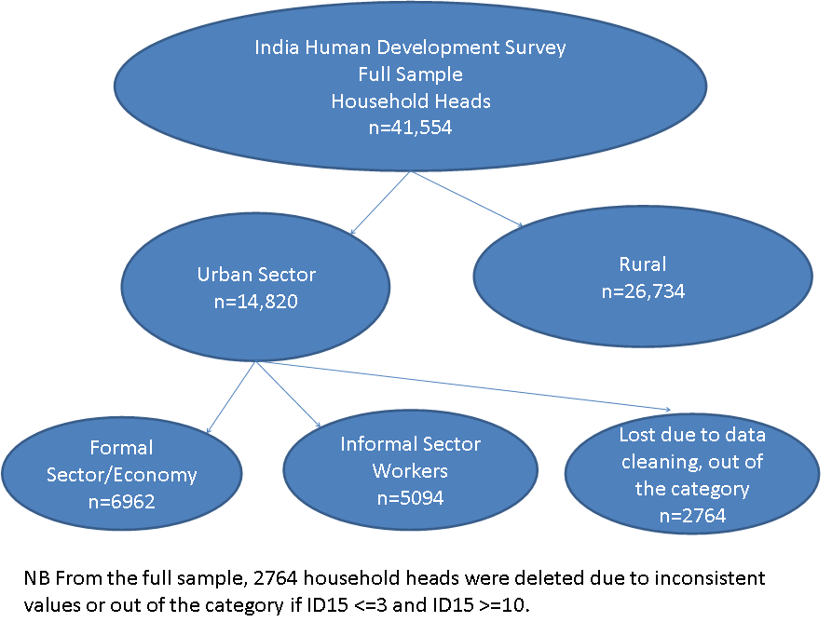

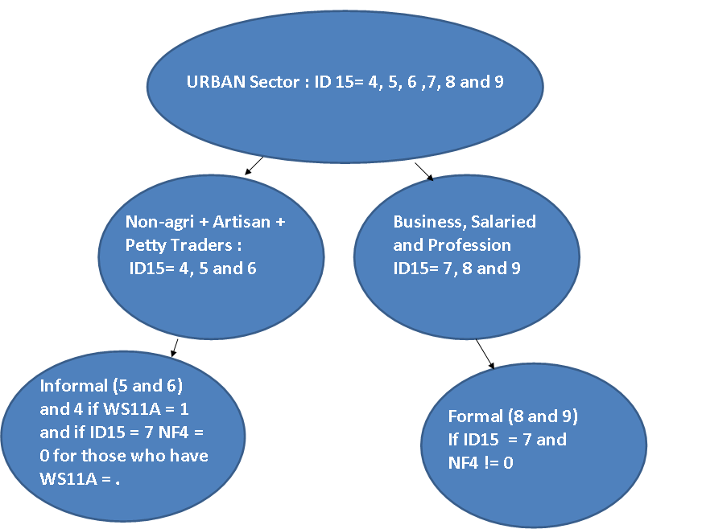

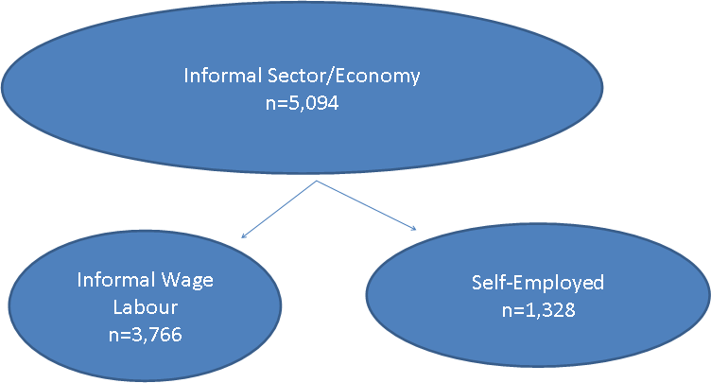

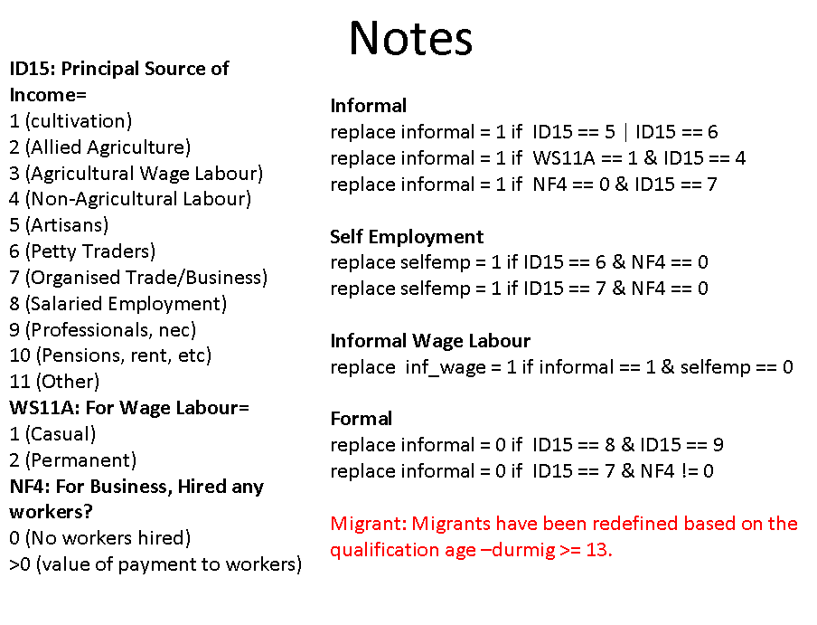

We are grateful for the provision of data by Desai, Sonalde, Reeve Vanneman, and National Council of Applied Economic Research, New Delhi, India. India Human Development Survey (IHDS), 2005 [Computer File]. ICSPSR22626-v7. Ann Arbor, MI: Inter-university Consortium for Political and Social Research [distributor], 2010-03-25. Doi: 10.3886/ICPSR22626.
An earlier version of this paper was presented to the Arndt-Corden School, ANU and we thank the participants for their helpful comments.
See Hnatkovska et al. (2012)
For robustness check we have run regressions without land holding variables and our regression remained consistent.

